Nora’s Bagel Bin Database Blueprints

**First Normal Form (1NF)**

|  |  |
| --- | --- |
| **BAGEL ORDER** | |
| PK | Bagel Order ID |
| PK | Bagel ID |
|  | Order Date |
|  | First Name |
|  | Last Name |
|  | Address 1 |
|  | Address 2 |
|  | City |
|  | State |
|  | Zip |
|  | Mobile Phone |
|  | Delivery Fee |
|  | Bagel Name |
|  | Bagel Description |
|  | Bagel Price |
|  | Bagel Quantity |
|  | Special Notes |

This is the original provided table of information in first normal form.

**PART A1: Complete the second normal form and explain the cardinality.**

**Second Normal Form (2NF)**

|  |  |  |  |  |  |  |  |
| --- | --- | --- | --- | --- | --- | --- | --- |
| **BAGEL ORDER** | |  | **BAGEL ORDER LINE ITEM** | |  | **BAGEL** | |
| PK | Bagel Order ID |  | PK / FK | Bagel Order ID |  | PK | Bagel ID |
|  | Order Date | 1:M | PK / FK | Bagel ID | 1:1 |  | Bagel Name |
|  | First Name |  |  | Bagel Quantity |  |  | Bagel Description |
|  | Last Name |  |  |  |  |  | Bagel Price |
|  | Address 1 |  |  |  |  |  |  |
|  | Address 2 |  |  |  |  |  |  |
|  | City |  |  |  |  |  |  |
|  | State |  |  |  |  |  |  |
|  | ZIP |  |  |  |  |  |  |
|  | Mobile Phone |  |  |  |  |  |  |
|  | Delivery Fee |  |  |  |  |  |  |
|  | Special Notes |  |  |  |  |  |  |

I began ordering the information in these tables by considering what the most relevant information is for each of them. The bagel order table contains all relevant information for the order and the customer information. For the line item table, I added the quantity seeing as it’s directly tied to the line item on the provided order form and it is independent of all the other tables. The bagel table contains all relevant information concerning specific bagels.

I believe that the order to the line item is a one-to-many relationship. An order can contain many line items, but a line item can only be associated with one order. For the next pair of tables, I believe that it is a one-to-one relationship. A line item can contain only the information for one type of bagel and one type of bagel can only be represented on one line item, based on the provided order form.

**PART A2: Complete the third normal form and explain the cardinality.**

**Third Normal Form (3NF)**

|  |  |  |  |  |  |  |  |  |
| --- | --- | --- | --- | --- | --- | --- | --- | --- |
| **ORDER INFORMATION** | | |  | **BAGEL ORDER LINE ITEM** | |  | **BAGEL** | |
| PK | Bagel Order ID | |  | PK / FK | Bagel Order ID |  | PK | Bagel ID |
| FK | Customer ID | | 1:M | PK / FK | Bagel ID | 1:1 |  | Bagel Name |
|  | Order Date | |  |  | Bagel Quantity |  |  | Bagel Description |
|  | Delivery Fee | |  |  |  |  |  | Bagel Price |
|  | Special Notes | |  |  |  |  |  |  |
|  | M:1 |  |  |  |  |  |  |  |
| **CUSTOMER INFORMATION** | | |  |  |  |  |  |  |
| PK | Customer ID | |  |  |  |  |  |  |
|  | First Name | |  |  |  |  |  |  |
|  | Last Name | |  |  |  |  |  |  |
|  | Address 1 | |  |  |  |  |  |  |
|  | Address 2 | |  |  |  |  |  |  |
|  | City | |  |  |  |  |  |  |
|  | State | |  |  |  |  |  |  |
|  | ZIP | |  |  |  |  |  |  |
|  | Mobile Phone | |  |  |  |  |  |  |

In order to get to the third normal form, I pulled out all of the customer specific information from the order table and made a new table titled “Customer Information.” I added in a new foreign key to the order table (Customer ID) and linked it to the primary key of the new customer table.

The cardinality for the top three tables remains the same. The cardinality between order information and customer information is a many-to-one relationship. An order can have at most one customer, but one customer can have several different orders.

**PART A3: Complete the physical database model and assign names and data types.**

**Final Physical Database Model**

|  |  |  |  |  |  |  |  |  |  |  |
| --- | --- | --- | --- | --- | --- | --- | --- | --- | --- | --- |
| **ORDER INFORMATION** | | |  | **BAGEL ORDER LINE ITEM** | | |  | **BAGEL** | |  |
| PK | bagel_order_id | INT |  | PK / FK | bagel_order_id | INT |  | PK | bagel_id | CHAR(2) |
| FK | customer_id | INT | 1:M | PK / FK | bagel_id | CHAR(2) | 1:1 |  | bagel_name | VARCHAR(40) |
|  | order_date | TIMESTAMP |  |  | bagel_quantity | INT |  |  | bagel_desc | VARCHAR(40) |
|  | delivery_fee | NUMERIC(2,0) |  |  |  |  |  |  | bagel_price | NUMERIC(3,2) |
|  | special_notes | VARCHAR(280) |  |  |  |  |  |  |  |  |
|  | M:1 |  |  |  |  |  |  |  |  |  |
| **CUSTOMER INFORMATION** | | |  |  |  |  |  |  |  |  |
| PK | customer_id | INT |  |  |  |  |  |  |  |  |
|  | first_name | VARCHAR(40) |  |  |  |  |  |  |  |  |
|  | last_name | VARCHAR(40) |  |  |  |  |  |  |  |  |
|  | address_1 | VARCHAR(100) |  |  |  |  |  |  |  |  |
|  | address_2 | VARCHAR(100) |  |  |  |  |  |  |  |  |
|  | city | VARCHAR(40) |  |  |  |  |  |  |  |  |
|  | state | CHAR(2) |  |  |  |  |  |  |  |  |
|  | zip | NUMERIC(5,0) |  |  |  |  |  |  |  |  |
|  | mobile_phone | NUMERIC(10,0) |  |  |  |  |  |  |  |  |

Jaunty Coffee Company

**PART B1: Develop SQL code to create each table and provide the code with verification.**

**Employee Table**

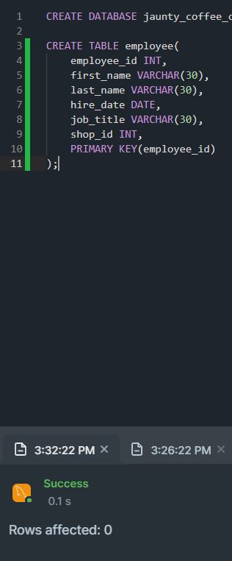

**Coffee Shop Table**

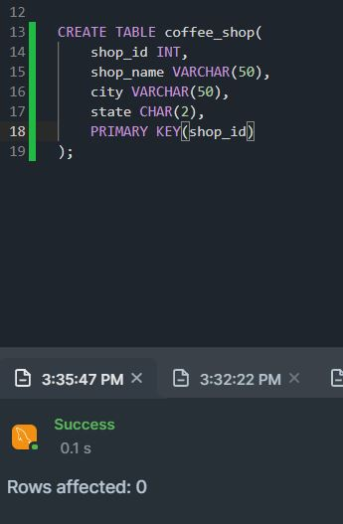

**Coffee Table**

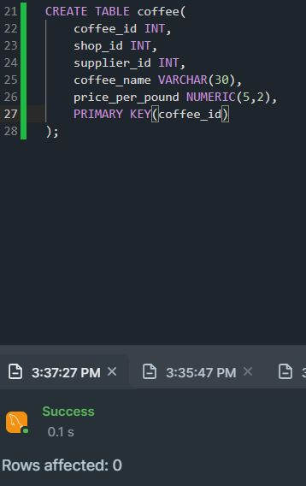

**Supplier Table**

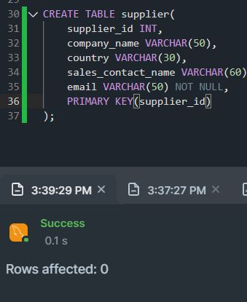

I added the foreign keys after the tables were created.

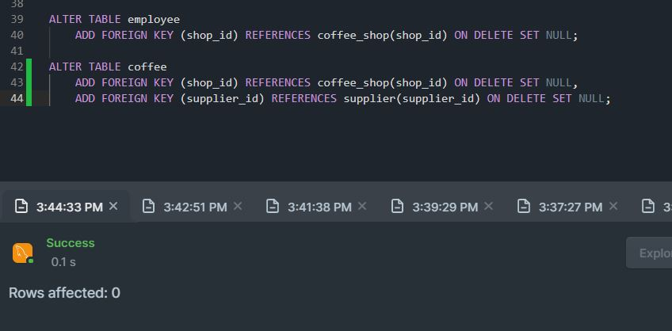

**Database Response**

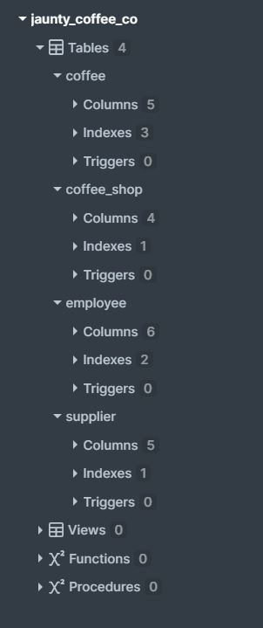

**PART B2: Populating each table with at least three rows of data**

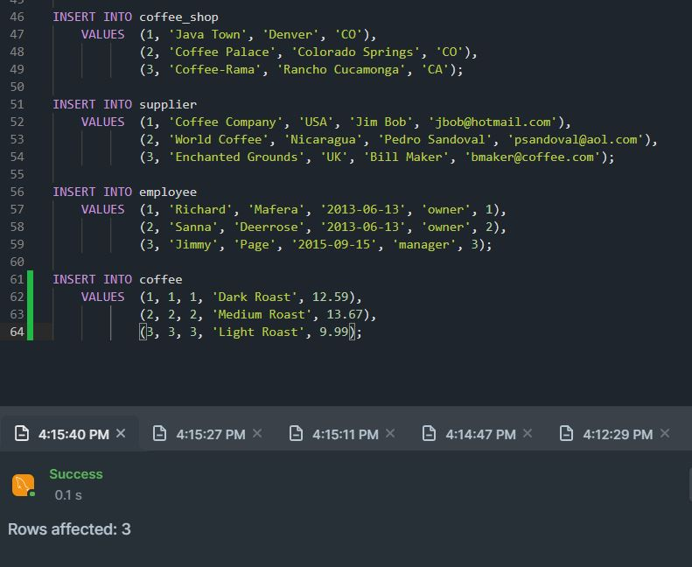

**PART B3: Develop a view with specific information.**

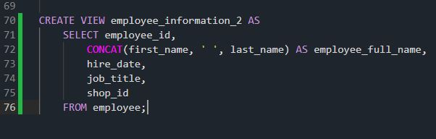

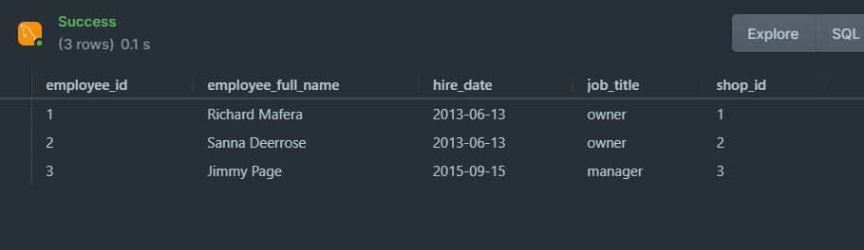

**PART B4: Create an index on the coffee name field.**

**PART B5: Create a SFW query for any of the tables or views.**

**PART B6: Create a join query for three tables.**

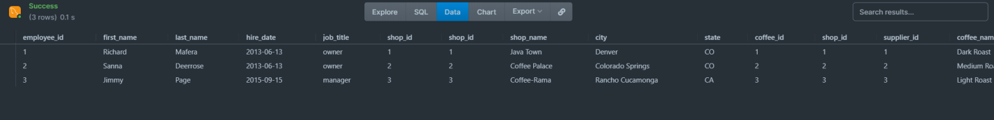

Note: The result is slightly too large to fit in the image. “price_per_pound” is still listed after “coffee_name.”